**WEEK 2 PLSQL EXCERCISES**

1. **Control Structures**

**Scenario 1:** The bank wants to apply a discount to loan interest rates for customers above 60 years old.

* + **Question:** Write a PL/SQL block that loops through all customers, checks their age, and if they are above 60, apply a 1% discount to their current loan interest rates.

-- Enable output (required to see DBMS_OUTPUT messages)

**CODE:**

SET SERVEROUTPUT ON;

BEGIN

-- Loop through all customers older than 60

FOR cust IN (

SELECT CustomerID, LoanID

FROM Customers

WHERE Age > 60

) LOOP

-- Apply 1% discount to the corresponding loan

UPDATE Loans

SET InterestRate = InterestRate - 1

WHERE LoanID = cust.LoanID;

-- Print confirmation message

DBMS_OUTPUT.PUT_LINE('1% discount applied to CustomerID: ' || cust.CustomerID);

END LOOP;

COMMIT; -- Save changes

END;

/

**Scenario 2:** A customer can be promoted to VIP status based on their balance.

**Question:** Write a PL/SQL block that iterates through all customers and sets a flag IsVIP to TRUE for those with a balance over $10,000.

**CODE:**

-- Enable output to view messages

SET SERVEROUTPUT ON;

BEGIN

-- Loop through customers with balance over 10,000

FOR cust IN (

SELECT CustomerID

FROM Customers

WHERE Balance > 10000

) LOOP

-- Update IsVIP flag to 'Y' (TRUE)

UPDATE Customers

SET IsVIP = 'Y'

WHERE CustomerID = cust.CustomerID;

-- Print confirmation message

DBMS_OUTPUT.PUT_LINE('Customer ' || cust.CustomerID || ' promoted to VIP status.');

END LOOP;

COMMIT; -- Save all changes

END;

/

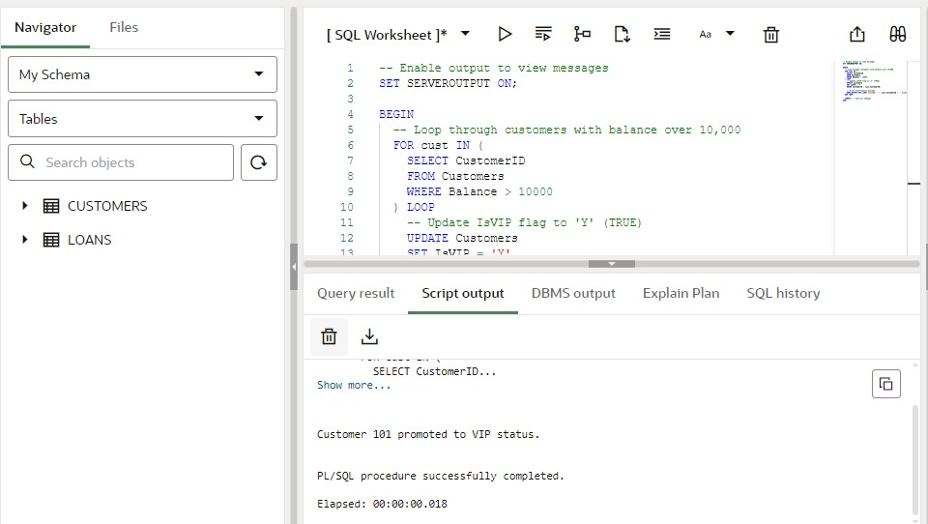

**Scenario 3:** The bank wants to send reminders to customers whose loans are due within the next 30 days.

* + **Question:** Write a PL/SQL block that fetches all loans due in the next 30 days and prints a reminder message for each customer.

**CODE:**

-- Drop the Loans table if it already exists

BEGIN

EXECUTE IMMEDIATE 'DROP TABLE Loans';

EXCEPTION

WHEN OTHERS THEN NULL;

END;

/

-- Create Loans table with correct columns

CREATE TABLE Loans (

LoanID NUMBER,

CustomerID NUMBER,

DueDate DATE

);

-- Insert test data

INSERT INTO Loans VALUES (201, 101, SYSDATE + 10); -- Due soon

INSERT INTO Loans VALUES (202, 102, SYSDATE + 35); -- Too late

INSERT INTO Loans VALUES (203, 103, SYSDATE + 5); -- Due soon

COMMIT;

-- Show reminders for loans due in next 30 days

BEGIN

FOR due_rec IN (

SELECT LoanID, CustomerID, DueDate

FROM Loans

WHERE DueDate <= SYSDATE + 30

) LOOP

DBMS_OUTPUT.PUT_LINE(

'Reminder: Loan ' || due_rec.LoanID ||

' for Customer ' || due_rec.CustomerID ||

' is due on ' || TO_CHAR(due_rec.DueDate, 'DD-MON-YYYY')

);

END LOOP;

END;

/

**2. Stored Procedures**

**Scenario 1:** The bank needs to process monthly interest for all savings accounts.

* + **Question:** Write a stored procedure **ProcessMonthlyInterest** that calculates and updates the balance of all savings accounts by applying an interest rate of 1% to the current balance.

**CODE:**

BEGIN

EXECUTE IMMEDIATE 'DROP TABLE Accounts';

EXCEPTION

WHEN OTHERS THEN NULL;

END;

/

CREATE TABLE Accounts (

AccountID NUMBER PRIMARY KEY,

Balance NUMBER,

AccountType VARCHAR2(20)

);

INSERT INTO Accounts VALUES (101, 1000, 'SAVINGS');

INSERT INTO Accounts VALUES (102, 2000, 'CHECKING');

INSERT INTO Accounts VALUES (103, 3000, 'SAVINGS');

COMMIT;

CREATE OR REPLACE PROCEDURE ProcessMonthlyInterest IS

BEGIN

UPDATE Accounts

SET Balance = Balance + (Balance * 0.01)

WHERE AccountType = 'SAVINGS';

-- Optional: count updated rows

DBMS_OUTPUT.PUT_LINE(SQL%ROWCOUNT || ' savings accounts updated.');

DBMS_OUTPUT.PUT_LINE('Monthly interest applied to all savings accounts.');

END;

/

SET SERVEROUTPUT ON;

BEGIN

ProcessMonthlyInterest;

END;

/

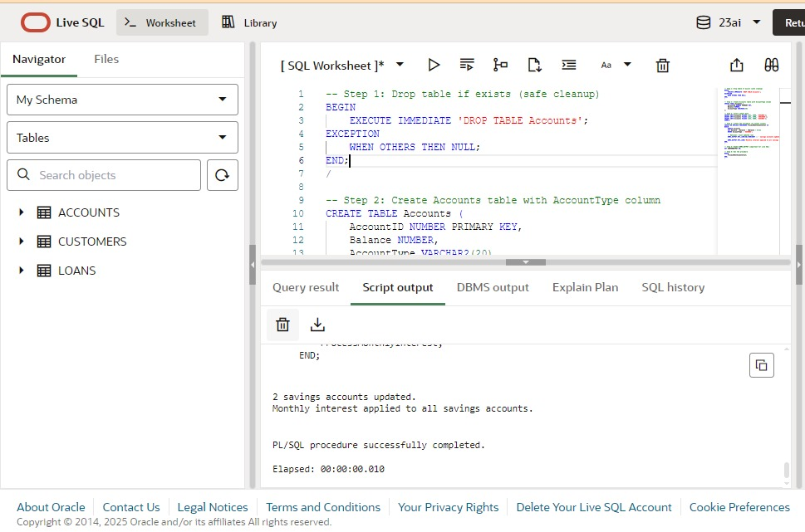

**Scenario 2:** The bank wants to implement a bonus scheme for employees based on their performance.

* + **Question:** Write a stored procedure **UpdateEmployeeBonus** that updates the salary of employees in a given department by adding a bonus percentage passed as a parameter.

**CODE:**

BEGIN

EXECUTE IMMEDIATE 'DROP TABLE Employees';

EXCEPTION

WHEN OTHERS THEN NULL;

END;

/

CREATE TABLE Employees (

EmployeeID NUMBER PRIMARY KEY,

Name VARCHAR2(50),

Department VARCHAR2(30),

Salary NUMBER

);

INSERT INTO Employees VALUES (101, 'Alice', 'HR', 40000);

INSERT INTO Employees VALUES (102, 'Bob', 'HR', 45000);

INSERT INTO Employees VALUES (103, 'Charlie', 'IT', 60000);

INSERT INTO Employees VALUES (104, 'David', 'IT', 65000);

INSERT INTO Employees VALUES (105, 'Eva', 'Finance', 50000);

COMMIT;

CREATE OR REPLACE PROCEDURE UpdateEmployeeBonus(

p_department IN VARCHAR2,

p_bonus_percent IN NUMBER

) IS

BEGIN

UPDATE Employees

SET Salary = Salary + (Salary * p_bonus_percent / 100)

WHERE Department = p_department;

DBMS_OUTPUT.PUT_LINE('Bonus of ' || p_bonus_percent || '% applied to ' || p_department || ' department.');

END;

/

BEGIN

UpdateEmployeeBonus('IT', 10);

END;

/

SELECT * FROM Employees;

**Scenario 3:** Customers should be able to transfer funds between their accounts.

**Question:** Write a stored procedure **TransferFunds** that transfers a specified amount from one account to another, checking that the source account has sufficient balance before making the transfer.

**CODE:**

BEGIN

EXECUTE IMMEDIATE 'DROP TABLE Accounts';

EXCEPTION

WHEN OTHERS THEN NULL;

END;

/

CREATE TABLE Accounts (

AccountID NUMBER PRIMARY KEY,

CustomerID NUMBER,

Balance NUMBER

);

INSERT INTO Accounts VALUES (101, 1, 5000); -- Source

INSERT INTO Accounts VALUES (102, 1, 2000); -- Target

COMMIT;

CREATE OR REPLACE PROCEDURE TransferFunds(

p_from_account IN NUMBER,

p_to_account IN NUMBER,

p_amount IN NUMBER

) IS

v_balance NUMBER;

insufficient_funds EXCEPTION;

BEGIN

SELECT Balance INTO v_balance

FROM Accounts

WHERE AccountID = p_from_account

FOR UPDATE;

IF v_balance < p_amount THEN

RAISE insufficient_funds;

END IF;

UPDATE Accounts

SET Balance = Balance - p_amount

WHERE AccountID = p_from_account;

UPDATE Accounts

SET Balance = Balance + p_amount

WHERE AccountID = p_to_account;

COMMIT;

DBMS_OUTPUT.PUT_LINE('Transferred ' || p_amount || ' from Account ' || p_from_account || ' to Account ' || p_to_account);

EXCEPTION

WHEN insufficient_funds THEN

DBMS_OUTPUT.PUT_LINE('Transfer failed: Insufficient funds in Account ' || p_from_account);

ROLLBACK;

WHEN NO_DATA_FOUND THEN

DBMS_OUTPUT.PUT_LINE('Transfer failed: One or both accounts do not exist.');

ROLLBACK;

WHEN OTHERS THEN

DBMS_OUTPUT.PUT_LINE('Unexpected error: ' || SQLERRM);

ROLLBACK;

END;

/

BEGIN

TransferFunds(101, 102, 1500);

END;

/

SELECT * FROM Accounts;

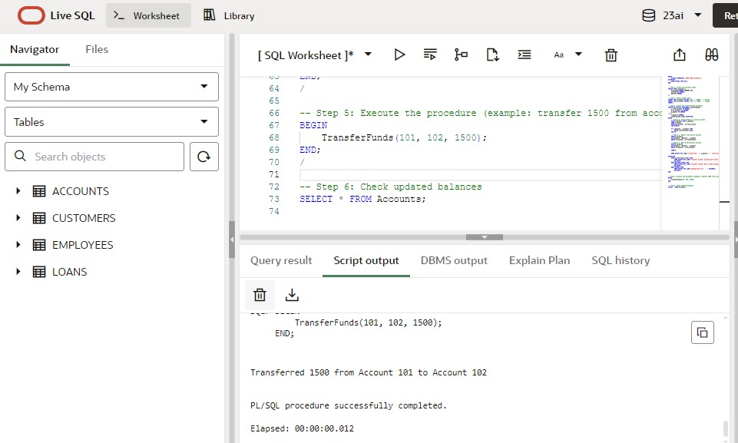

**WEEK 2 JUNIT BASIC TESTING EXERCISE**

1. Setting Up JUnit Scenario: You need to set up JUnit in your Java project to start writing unit tests.

Steps:

1. Create a new Java project in your IDE (e.g., IntelliJ IDEA, Eclipse).

2. Add JUnit dependency to your project. If you are using Maven, add the following to your pom.xml:

3. Create a new test class in your project.

**CODE:**

package com.example;

public class Calculator {

public int add(int a, int b) {

return a + b;

}

}

package com.example;

import org.junit.Test;

import static org.junit.Assert.assertEquals;

public class CalculatorTest {

@Test

public void testAdd() {

Calculator calc = new Calculator();

int result = calc.add(5, 3);

assertEquals(8, result);

}

}

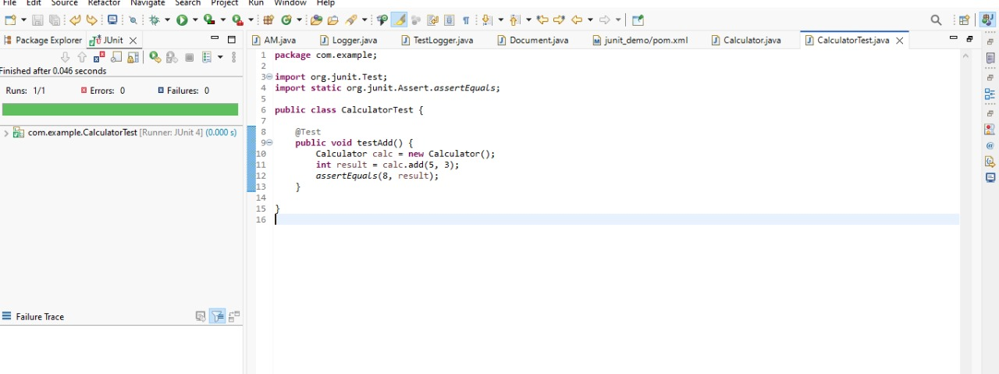

2. Assertions in JUnit Scenario: You need to use different assertions in JUnit to validate your test results.

Steps:

1. Write tests using various JUnit assertions.

**CODE:**

package com.example;

import static org.junit.Assert.*;

import org.junit.Test;

public class AssertionsTest {

@Test

public void testAssertions() {

// Assert equals

assertEquals(5, 2 + 3);

// Assert true

assertTrue(5 > 3);

// Assert false

assertFalse(5 < 3);

// Assert null

assertNull(null);

// Assert not null

assertNotNull(new Object());

}

}

3. Arrange-Act-Assert (AAA) Pattern, Test Fixtures, Setup and Teardown Methods in JUnit

Scenario: You need to organize your tests using the Arrange-Act-Assert (AAA) pattern and use setup and teardown methods.

Steps:

1. Write tests using the AAA pattern.

2. Use @Before and @After annotations for setup and teardown methods.

**CODE:**

package com.example;

public class Calculator {

public int add(int a, int b) {

return a + b;

}

public int subtract(int a, int b) {

return a - b;

}

}

package com.example;

import static org.junit.Assert.*;

import org.junit.After;

import org.junit.Before;

import org.junit.Test;

public class CalculatorTest {

private Calculator calculator;

@Before

public void setUp() {

// Arrange: setup before each test

calculator = new Calculator();

System.out.println("Setup: Calculator created");

}

@After

public void tearDown() {

// Cleanup after each test

calculator = null;

System.out.println("Teardown: Calculator reset");

}

@Test

public void testAddition() {

// Arrange is already done in setUp()

// Act

int result = calculator.add(2, 3);

// Assert

assertEquals(5, result);

}

@Test

public void testSubtraction() {

// Act

int result = calculator.subtract(10, 4);

// Assert

assertEquals(6, result);

}

}

**WEEK 2 MOCKITO EXERCISES**

1.Mocking and Stubbing Scenario: You need to test a service that depends on an external API. Use Mockito to mock the external API and stub its methods.

Steps:

1. Create a mock object for the external API.

2. Stub the methods to return predefined values.

3. Write a test case that uses the mock object.

**CODE:**

package com.example;

public interface ExternalApi {

String getData();

}

package com.example;

public class MyService {

private ExternalApi api;

public MyService(ExternalApi api) {

this.api = api;

}

public String fetchData() {

return api.getData();

}

}

package com.example;

import org.junit.Test;

import static org.junit.Assert.*;

import static org.mockito.Mockito.*;

public class MyServiceTest {

@Test

public void testExternalApi() {

ExternalApi mockApi = mock(ExternalApi.class);

when(mockApi.getData()).thenReturn("Mock Data");

MyService service = new MyService(mockApi);

String result = service.fetchData();

assertEquals("Mock Data", result);

}

}

2.Verifying Interactions Scenario: You need to ensure that a method is called with specific arguments. Steps:

1. Create a mock object.

2. Call the method with specific arguments.

3. Verify the interaction.

package com.example;

**CODE:**

import static org.mockito.Mockito.*;

import org.junit.Test;

public class MyServiceTest {

@Test

public void testVerifyInteraction() {

ExternalApi mockApi = mock(ExternalApi.class);

MyService service = new MyService(mockApi);

service.fetchData();

// Verify that getData() was called once

verify(mockApi).getData();

}

}

package com.example;

public interface ExternalApi {

String getData();

}

package com.example;

public class MyService {

private ExternalApi api;

public MyService(ExternalApi api) {

this.api = api;

}

public String fetchData() {

return api.getData();

}

}

**WEEK 2 SL4J LOGGING EXERCISES**

1. Logging Error Messages and Warning Levels Task: Write a Java application that demonstrates logging error messages and warning levels using SLF4J.

**CODE:**

package com.example;

import org.slf4j.Logger;

import org.slf4j.LoggerFactory;

public class LoggingExample {

private static final Logger logger = LoggerFactory.getLogger(LoggingExample.class);

public static void main(String[] args) {

logger.error("This is an error message");

logger.warn("This is a warning message");

}

}

